PAWDIUM WELLNESS PET SUPPLIES TRADING SALES AND INVENTORY SYSTEM
Test Summary Report
Version <1.0>
<11/22/2022>

VERSION HISTORY

Version # | Implemented  By | Revision  Date | Approved  By | Approval  Date | Reason
1.0 | JC. Velasquez | 11/21/2022 |  |  | Additional functions
1.0 | JC. Velasquez | 11/22/2022 |  |  | Additional functions
1.0 | A. Enriquez | 11/24/2022 |  |  | Additional functions
 | C. Igdoy | 11/25/2022 |  |  | Additional functions
1.0 | JC. Velasquez | 11/26/2022 |  |  | UAT Adjustment
Template Version: 1.0

Introduction

Purpose
This Pawdium Wellness Pet Supplies Trading Sales and Inventory System Test Report provides a summary of the results of the test performed as outlined within this document.

Test Summary
Project Name: Pawdium Wellness Pet Supplies Trading Sales and Inventory System
System Name: Pawdium Wellness Pet Supplies Trading Sales and Inventory System
Version Number: 1.0
Additional Comments: N/A

INTEGRATION TESTING
During Integration Testing all of the functions are tested. Ensuring that all of the required functions and system flow are met.
Test Owner: Justine Claire Velasquez, Abbigail Enriquez, Cialrisse Igdoy
Test Date: 11/21/2022 - 11/22/2022
Test Results:
User Access and Permissions: PASSED
Sprint 1- Iteration 1: PASSED
Iteration 2: PASSED

REGRESSION TESTING
During Integration Testing all of the functions are tested. Ensuring that all of the required functions and system flow are met.
Test Owner: Justine Claire Velasquez, Abbigail Enriquez, Cialrisse Igdoy
Test Date: 11/22/2022 - 11/23/2022
Test Results:
User Access and Permissions: PASSED
Sprint 1- Iteration 1: PASSED
Iteration 2: PASSED

uSER-ACCEPTANCE TESTING
During Integration Testing all of the functions are tested. Ensuring that all of the required functions and system flow are met.
Test Owner: Pawdium Wellness Pet Supplies Trading
Test Date: 11/24/2022 - 11/26/2022

Test Results:
User Access and Permissions: PASSED
Sprint 1- Iteration 1: PASSED
Iteration 2: PASSED

Test Assessment

During the testing, a comprehensive manual testcase was employed. Because Agile was employed, incremental testing with integration and regression is appropriate for the system.

Manual Sprint Testcase:

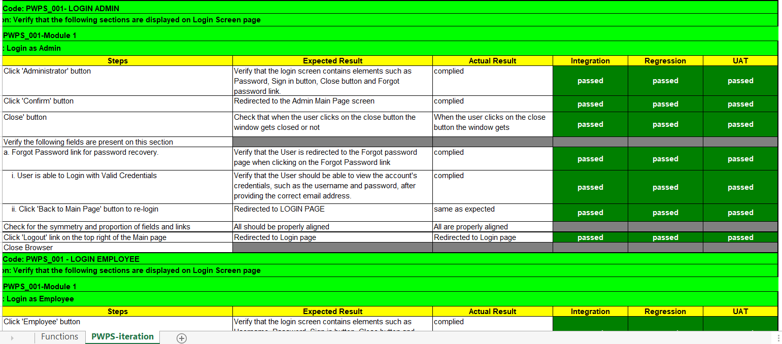

Test Results
Agile testing maintains that continuous monitoring, like programming, is an integral part of development. We chose the technology, spoke about the options for the application's architecture, and made a prototype with the client. Starting with the project's creation, the end user is involved, and their participation is essential.
The system has been verified to be free of bugs and errors after the team conducted numerous tests, including performance and other testing processes. Testing is carried out whenever new code is incorporated into the system. The developed system is tested for every function using agile testing. To check whether each function works despite ongoing changes, testcases are produced using the test scenarios during each cycle. User acceptance testing, regression testing, and integration testing were all used to test the system. The strength and integrity of the data and functions will be validated over the course of one full Sprint and several iterations. Overall, all the flaws have been fixed, and the system is now prepared for usage.

SuggEstED aCTIONS
If the end-user had suggestions for improving the system's dependability and effectiveness, such as modifying a feature or adding a function, they merely had to contact us.
Test Summary Report Approval
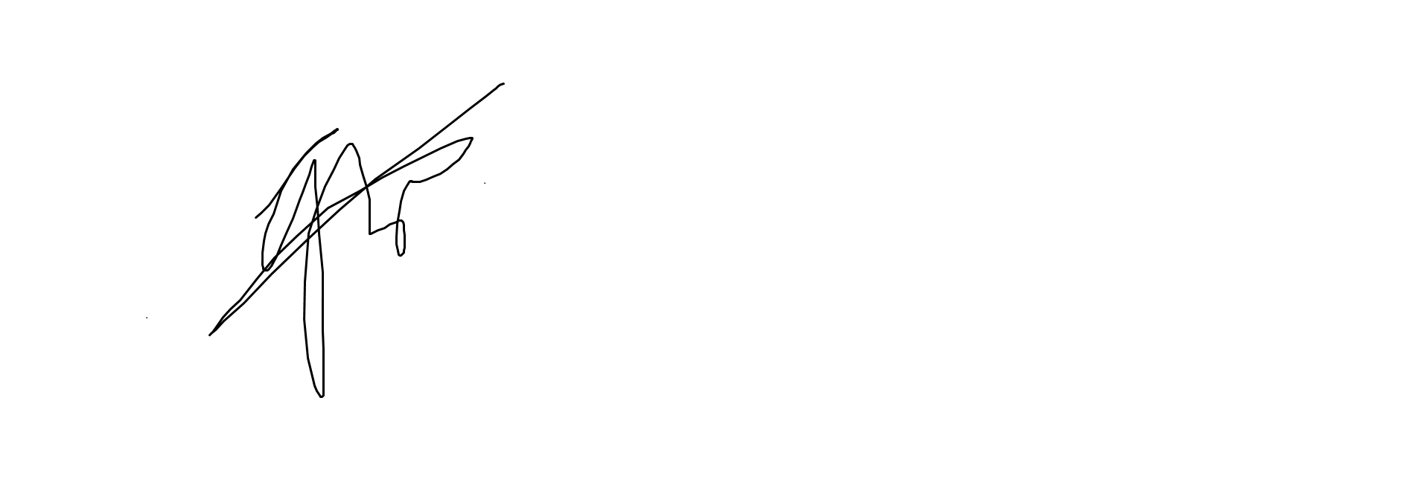
The undersigned acknowledge they have reviewed the Sales and Inventory for Pawdium Wellness Pet Supplies Trading Test Summary Report and agree with the approach it presents. Changes to this Test Summary Report will be coordinated with and approved by the undersigned or their designated representatives.

Signature: |  | Date: | 08/012022
Print Name: | Engr. Greta M. Rosario
Title: | Senior Software Quality Assurance Specialist
Role: | SQA Lead

Signature: |  | Date:
Print Name:
Title:
Role:

Signature: |  | Date:
Print Name:
Title:
Role:

KEY TERMS
The following table provides definitions for terms relevant to this document.
Term | Definition
Manual Testcase | [Provide definition of the term used in this document.]
[Insert Term] | [Provide definition of the term used in this document.]
[Insert Term] | [Provide definition of the term used in this document.]

